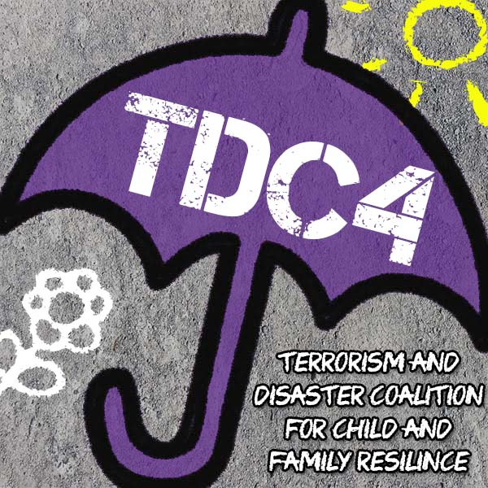

Hurricane Preparedness for Expectant Parents
Experiencing a hurricane and its aftermath can be challenging, especially for expectant parents. However, planning ahead can help families get through a hurricane safely and ease some of the distress it can cause. This handout reviews steps expectant parents should consider when preparing for hurricane season or before a storm is coming.
- Develop an Evacuation Plan
Evacuating can help ensure continuous prenatal care and minimize exposure to harmful toxins sometimes present after hurricanes, both of which are important for the health and safety of mothers and babies. Make a plan now, for how and where you might evacuate should it be necessary.
- Plan how you will leave and where you will go.
  - Identify at least two places you could stay in another town, such as the house of a family or friend, or a hotel.
  - Learn your evacuation zone and evacuation routes ahead of time.
  - If you do not have transportation, figure out where your closest “evacuation spot” is located. Call 2-1-1 or go to www.211.org for assistance.
  - Put your plan in writing.
- Identify where you could get medical care close to your chosen evacuation sites, including the closest hospitals or medical clinics.
- Follow all official evacuation recommendations but consider leaving earlier to ensure your safety and avoid complications.
- Make a plan for communicating and reuniting with loved ones and family members.
- Don’t forget to accommodate for your pets as not having a plan can add to your stress especially if you must leave them behind in an evacuation.

- Put Together an Emergency Kit
In addition to a typical emergency kit (such as food and water, first aid supplies, flashlights and batteries, and hygiene supplies), prepare enough supplies for at least 5 days, or more if instructed. Pack your emergency kit in a way that you can take with you if you must evacuate.
- Expectant mothers should also include prenatal vitamins, extra water and nutritious snacks.
- Comfortable clothes, blankets, and needed feeding items should also be included to welcome and tend to the needs of a new baby.
- Refer to www.ready.gov for additional ideas of items to include in your emergency kit.

- Make a Plan with Your Doctor/Medical Provider
Every pregnancy is different, so it is important to discuss your needs with your doctor or care provider and make a plan that fits for you and your family. Here are some important questions to ask:

Pregnancy-Related Medical Questions to Consider:
- What are the signs and symptoms of pre-term labor and/or that I should I seek immediate medical attention?
- If my pregnancy is considered “high-risk”, are there other steps I should take to prepare for a hurricane?
- Given my unique circumstances, how early should I plan on evacuating to be sure I can always access adequate medical care?
Provider-Related Questions, Referrals or Recommendations to Consider:
- If I need to seek care in a new location or with a new provider:
  - How do I obtain a copy of my medical records?
  - Are there any key things I need to inform them about my pregnancy?
- How will I be notified if any of my medical providers evacuate or change due to a hurricane?
  - Is there an emergency number I can call if I have questions about my pregnancy?
- How might my care be affected if my clinic or hospital closes or procedures change during a hurricane?
- How can I get information about what hospitals/facilities are offering prenatal care or other services during a storm to support me with my pregnancy?

- Create a Stress Management Plan
While it’s normal to experience stress and anxiety during pregnancy, the added stress and disruption of experiencing a hurricane can have negative physical and mental health effects on expectant parents. Here are some tips for managing and reducing stress during this time especially if you recognize your stress goes above and beyond pregnancy-related challenges:

Know the Signs of Stress:
- Changes in eating or sleeping patterns
- Irritability, feeling uneasy, or having a “short fuse”
- Feeling withdrawn, restless, or isolating yourself
- Lack of energy, motivation, or being unable to care for yourself
- Physical symptoms including: headaches, stomach aches, racing heartbeat
- Increasing use of alcohol and/or other substances to “self-medicate”
Take These Steps:
- Identify sources of stress and talk about them with someone you trust
- Make time for adequate sleep
- Follow your doctor’s recommendations for diet and exercise
- Make time for self-care activities and doing things you enjoy
- If you need a mental health professional, call 2-1-1 to learn about the resources in your area or ask your doctor for a qualified referral
If You are Having Thoughts of Harming Yourself
- Talk to your doctor or counselor immediately
- If you need immediate medical help, go to your nearest emergency room or call 9-1-1
- The National Suicide Prevention Lifeline is also available 24/7 at (800) 273-8255
- Identify Your Social Supports
Social support is one of the most protective factors against stress. While important throughout pregnancy, it is even more important when also planning for a hurricane. Identifying and fostering supports ahead of time can help expectant parents feel more connected, less isolated, and confident that others will be there.

Consider who can provide the following support:
- Someone to talk to about my feelings and worries
- Someone else who is also expecting a baby and coping with pregnancy
- Someone who can support me during an evacuation, if I go into labor, or need medical attention
- Someone I can trust to watch my other children as I attend to the needs of my current pregnancy
Parenting support groups, online parenting forums, and other community groups can also be helpful during this time.
Hurricanes can disrupt social support networks. Consider:
- How can I continue to stay in contact with my supports before, during, and after a storm? (cell phones and internet may not be available or reliable)
- Are there additional supports at my evacuation sites with whom I can connect?
Additional Resources:
- American Red Cross: (866) 438-4636 or (800) 733-2767
- Federal Emergency Management Agency (FEMA) Preparedness Resources: www.ready.gov
- American College of Obstetricians and Gynecologists – Patient Resources: https://www.acog.org/patients
- TDC4: https://www.medschool.lsuhsc.edu/tdc
- SAMSHA Disaster Distress Helpline: (800) 985-5990
- National Domestic Violence Hotline: (800) 799-7233

